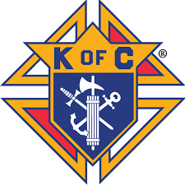
Msgr. John’ Knights of Columbus Council #11836
of St. Anne’s parish will be having the Empire Safety Council Defensive Driving Course on Saturday July 31st, from 9:00AM to 3:00PM
Save 10% on your collision liability rates for three full years, as well as four (4) points on driving violations
We recommend that New Drivers and Teenagers also take this course, not only for the insurance discounts,but for their “SAFETY”
65-70% of Accidents are due to TEXTING while driving and 40% are due to Alcohol
There will be a lunch break, as free donuts and coffee will be available
Please makeyour check payable to the Knights of Columbus Council #11836 in the amounrt of $45.00. You can either mail or bring your check to St.Anne’s rectory.
St. Annes Parish
35 Dartmouth Street Garden City New York 11530
Attention Defensive Driving

Name:_____________________________________________________________________

Address:___________________________________________________________________

E-Mail Address:_____________________________________________________________

Telephone # _______________________________________________________________

We would appreciate your confirmation no later then July 28th 2021 to notify Empire Safety

For additional information contact Donald J DePol ( 516-775-3097 )

Note - we will be following any CDC requirements in effect at the time of the
Defensive Driving Course

